Newsletter
Issue 6

13 October 2023

Dear Parents and Carers

It was lovely to see so many of you at Parent’s evenings this week and I really enjoyed being able to have a chat with so many of you. Thank you for all your positive comments about the work your children are doing and the targets the teachers are setting for them.

I have noticed some amazing art in Year 2 this week. The sketching that the children were doing was of such a high standard – I was amazed!

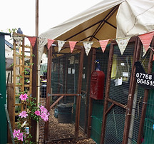
We have talking to the children about the upcoming retirement of our beautiful but elderly hens. They will be leaving us on Monday for a pre-retirement holiday at the hen hotel in Bishops Waltham (I didn’t believe there was such a thing when I was first told about it!) They will then have a quieter life being looked after by Linda Courtney (our Governing body co-chair) who will be able to give them the care and attention they need over the winter. Thank you to all the children and their families who have come to feed them over the weekends for the past few years. We will miss our girls but will enjoy getting photos of them in their new home.

Here is a picture of the Hen Hotel – I think they will be well looked after on their holiday.

Year 1 and 2
On Thursday, Year 1 and 2 received a visit from a wonderful storyteller called Amanda Kane-Smith. They learned how to tell traditional tales and fables in imaginative and captivating ways. All of the children seemed to have a fabulous time, so please ask them about it at home!

Menu Changes
There will be a slight change to the Red Option for Monday 16 October – the option will be: Chicken Meatballs with pasta – not chicken meatball sub and potatoes.

Also, on Wednesday 18 October the Red Option will be Sausages – the Green Option is unchanged (Pizza)

Scarecrow Competition
The annual Oliver’s Battery Scarecrow Competition will be held 27 October – 6 November. You are invited to enter either the family, adult or groups categories. All entries to be received by 27 October and displayed between 27 October and 6 November. We have some entry forms in the school office or email: oliversbatteryevents@gmail.com.
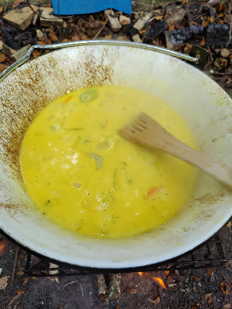
Forest School
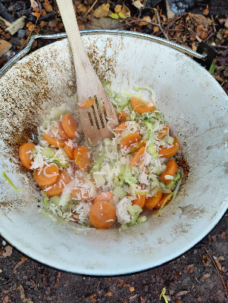
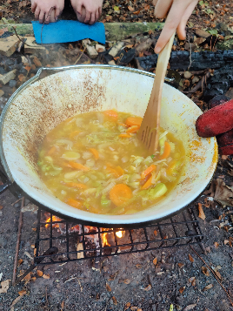
Mrs Morris, one of our Forest School Leaders, has been working with her Year 6 intervention group and this week they worked together to cook some Thai coconut soup over the fire. They chopped the vegetables in school before cooking them over the fire along with some basmati rice, vegetable stock and coconut milk. The children prepared the vegetables and took turns in stirring the soup over the fire.

360 Sports Coaching
360 Degree Sports Coaching are running an half term holiday camp at Weeke Primary School from 23 – 27 October – 8.30am – 5.30pm at a cost of £25.00 per day. This is open to children age 5 – 12 years and will involve sports, art and craft and team games. For more information go to; info@360degreesportscoaching.com.

School Photographer
Date for your diary – the school photographer will be in school on Thursday 16 November to take individual and sibling pictures. The orders will be ready in time for Christmas.

Flu Immunisations
The school nursing team will be in school on Tuesday 5 December to deliver the flu vaccinations to all children in Year R through to Year 6.

A separate parentmail has been sent out this week to enable you to sign up if you would like your child to receive the vaccination.

New Menu
A new menu has been sent home this week which will commence after half term. The kitchen team are also offering the children a Jacket Potatoes option. If you would like a paper copy of the menus please contact the school office.

Year R School Applications
If your child is four, or will turn four before 1 September 2024, they can start school in September 2024. For more information go to www.hants.gov.uk/admissions Applications are open from 1 November 2023 and will close on Monday 15 January 2024.
Secondary School Applications
Secondary School place applications for September 2024 are now open and will close on Tuesday 31 October 2023. Parents and Carers with children due to move to secondary school next year can now apply for their child’s school place. Applications can be submitted online or paper forms can be requested by emailing admissions.team@hants.gov.uk.

Halloween Disco
Date for your diary – the PTA have organised a Halloween Disco, taking place on Thursday 19 October. KS1 and Nursery from 5pm – 6pm and KS2 from 6.30pm – 7.30pm. Prizes for best homemade costumes. The cost is £3.00 per entry which includes drinks, sweets and games. Please note Parent/Carers must stay with Nursery Children.

Learning Behaviours
We have held this week’s Learning Behaviours assembly. This is where each teacher chooses a child/children that has demonstrated the chosen learning behaviour of the week. The teacher shares with everyone what the child has done and then we all celebrate their achievement. This term we are looking at respect. The children who were chosen this week were:

Year One Lily and Isla

Year Two Ema

Year Three Dylan

Year Four Theo

Year Five Wilf

Year Six Ellen

School Lunches
Thank you to everyone for settling their lunch accounts, however the lunch debts are still high - please could you ensure that your account is kept up to date. For your information the money owed per class is as follows:-

Hares £ 158.33
Foxes £ 42.95
Herons £ 171.30
Kingfishers £ 154.30
Nursery £ 52.40

From Monday 18 September your child will not be able to order a school lunch if the debt is above £10.00 – if the debt is over £10.00 they will need to bring in a packed lunch. Please can you arrange to clear your Lunch accounts as soon as possible.

If you would like an up to date statement of your child’s account please contact the Admin Team. If you have not yet registered to pay online via Scopay and would like a copy of your login details please email us and we will be happy to help. We would appreciate it if all accounts, including any outstanding Breakfast Club and After School Club accounts, could be settled as soon as possible. Please ensure that your After School Club Account is up to date as we employ extra staff for this club. If you would like an up to date statement please contact the school office.

Thank you for your continued support.

Yours faithfully

Mrs Bordoli
Interim Headteacher

Dates for your diary (new dates in red)

Open Morning (9.30am) 19 October 2023
Halloween Disco 19 October 2023
School breaks up for half term 19 October 2023
Inset Day 20 October 2023
School returns 30 October 2023
Secondary School Applications close 31 October 2023
School Photographer 16 November 2023
Open Morning (9.30am) 29 November 2023
Flu Vaccinations 5 December 2023
Whole School Trip to Cinderella 14 December 2023
School breaks up for Christmas 15 December 2023
School returns for Spring term 2 January 2024
Open Morning (9.30am) 5 January 2024
Year R school applications close 15 January 2024
Inset Day 19 February 2024
Inset Day 28 June 2024
Inset Day 1 July 2024

